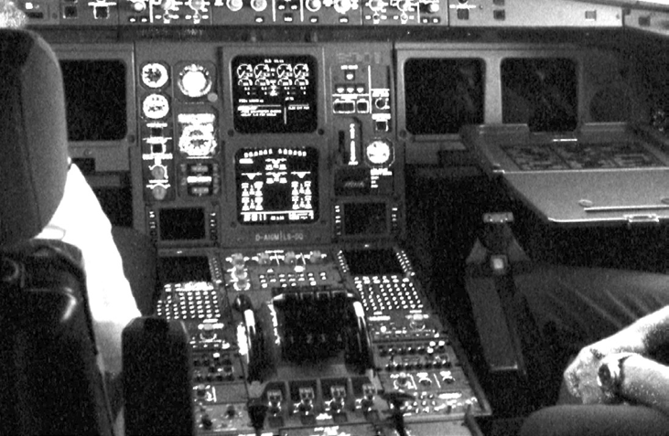

**Our First Module**

***Objective: Revisit Lab 3, build and load a*** hello world ***module into the Linux kernel. Module licensing will be introduced and finally you will verify the module was loaded correctly by observing the system log for the running kernel.***

1. Start Eclipse from Desktop
2. In the Project Explorer, right-click and select New, C-Project. In the dialogue window call the Project Name “Lab4” and selection Linux GCC for the toolchain:
3. Click next and keep both “Debug” and “Release” configurations. Click “Finish”.
4. Right click on the “Lab4” project in Project Explorer, select New, File and call the file “lab4.c”. Create another file and call it “Makefile”.
5. The contents of Makefile will be the same as the one given in Lab 3 with the exception of the obj file name “lab4.o”.
6. In kernel 2.4 and later, a mechanism was devised to identify code licensed under the GPL so people can be warned that the code is non open-source. This is accomplished by the MODULE_LICENSE () macro which is demonstrated in this first module. By setting the license to GPL, you can keep the warning from being printed. This license mechanism is defined and documented in linux/module.h.
7. The following code will create our first module:

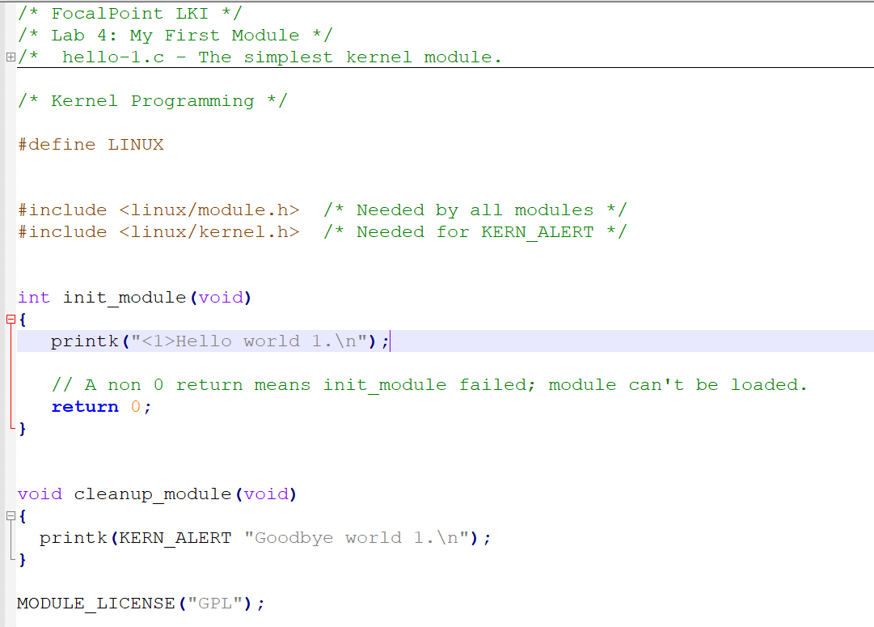

1. Create Make Targets for “all” and “clean”.
2. Finally run the “make all” target and observe the console window. You should have a clean compilation free of errors. If you do not, please let the instructor know as you probably have an issue with your development environment which needs to be fixed for future labs.

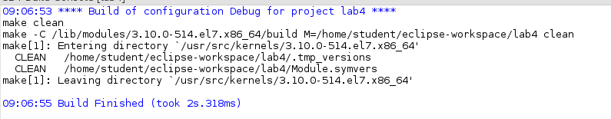

1. To load your module start a command console (right-click on your desktop and Open Terminal).
2. Change directory to your workspace “Lab4” folder (see the console build output from step 9 for your specific directory).
3. The kernel module is called “lab4.ko”. To load it you will need to run the command “sudo /sbin/insmod ./lab4.ko” and enter the root password “password”.
4. To observe our debug print statement you can dump the messages log with the command “sudo tail /var/log/messages”.

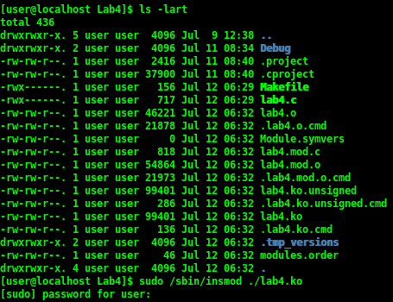

1. Finally to unload the module and observe the exit printing out to the debug log issue the command “sudo /sbin/rmmod lab4” and dump the log file as before.

